SME Account Creation Steps
- NBRC sends invite
- You should receive an email (within 5 min of sending invite) that looks like below
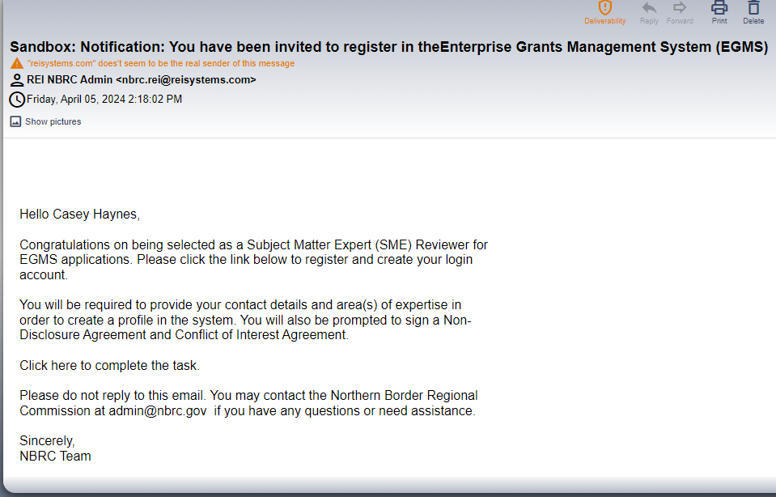
- Click link in email
- Agree to 2 acknowledgments
- Fill out
- SME reviewer profile
- Detailed profile
- Area of Expertise
- Hit Save
- Click checkbox with captcha
- Click Submit
- Screen should show confirmation message
  - Please note that your account doesn’t ‘exist’ in the system until you’ve completed steps 2-8. You won’t be able to request your own password reset until the account is created.
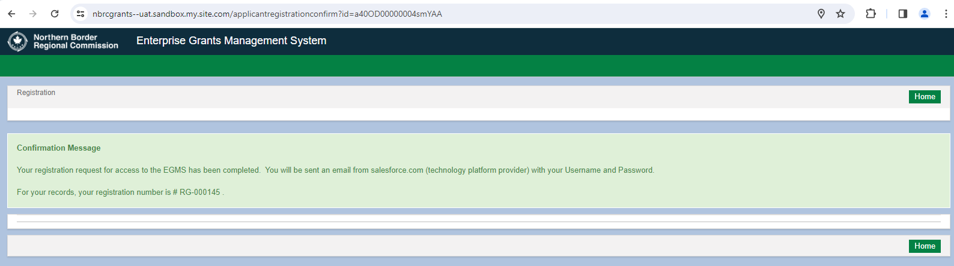
- Open email (within 5 min of sending invite)
  - Take note of the username. It will most often be your email, but the system can sometimes add a ‘1’ in the mix, so in the example below, I could have ended up with the username caseytestsme1@yopmail.com which is what I would then have to sign in with going forward.
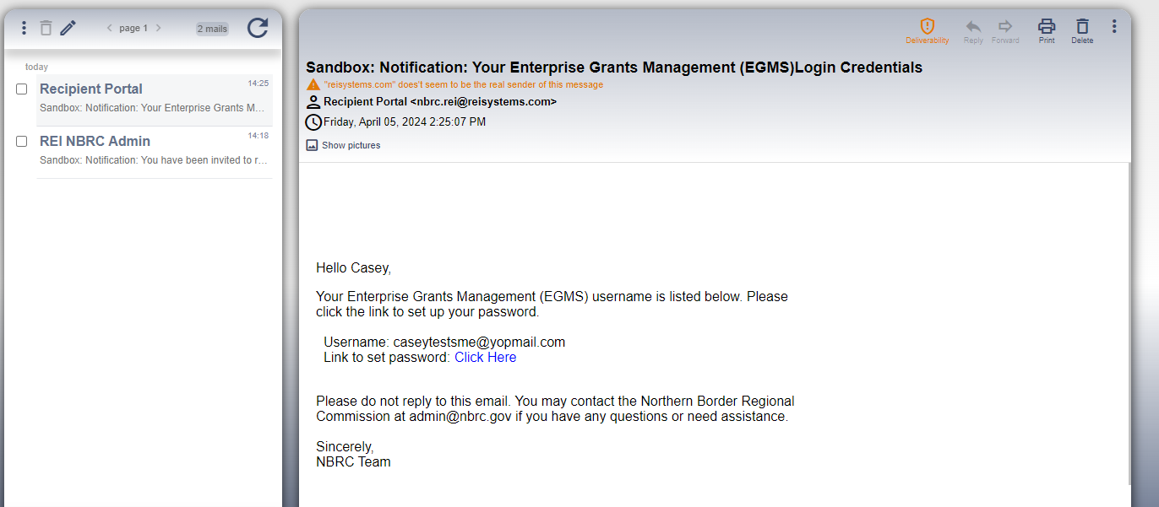
- Create your password
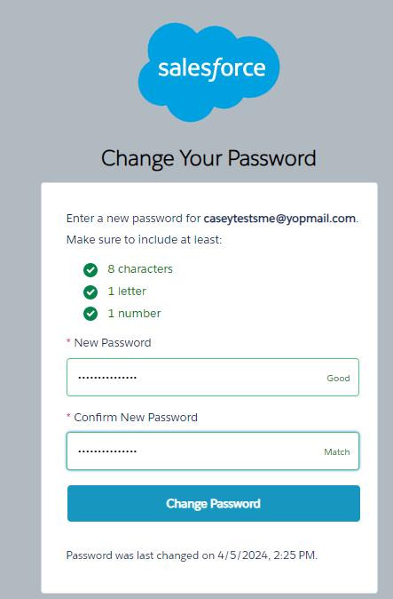
- Click Change Password
- Takes you to home page – you’re done!
Using PW reset (if you have previously completed steps 2-8 above)
- Click “Forgot Password” on the grant portal
- Enter your username
  - Again, it is 98% of the time the email address you signed up with, but if NBRC staff can confirm for you if you’re not 100% sure what your username is
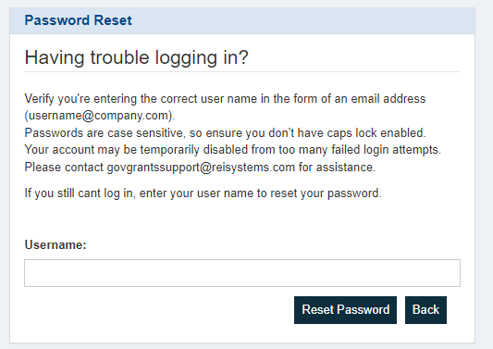
- Click Reset Password; you should see the following message:
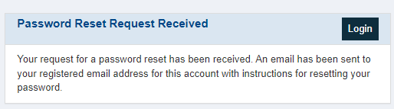
- Find the email (should arrive within 5 minutes)
- Click the link
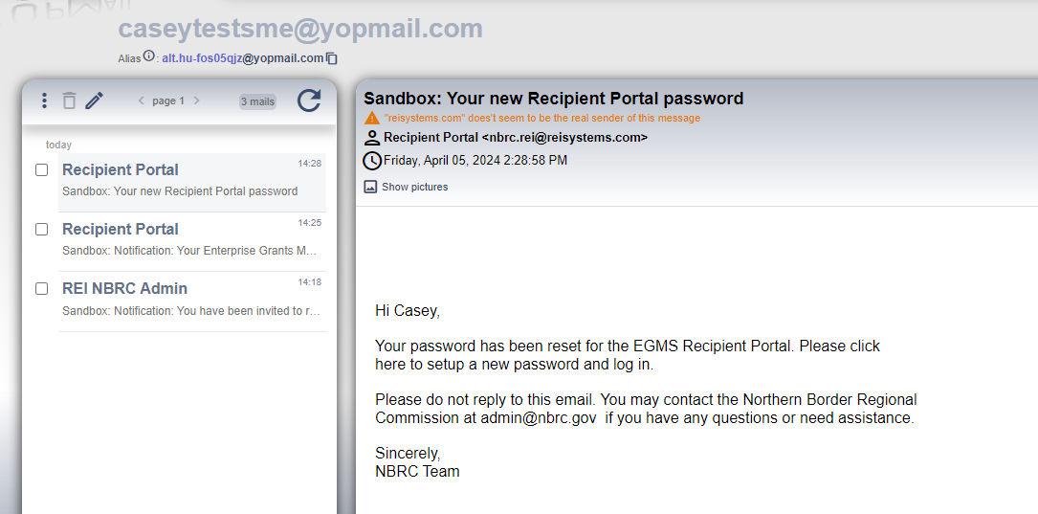
- You should be taken to the password reset page, similar to steps 11-13 above

